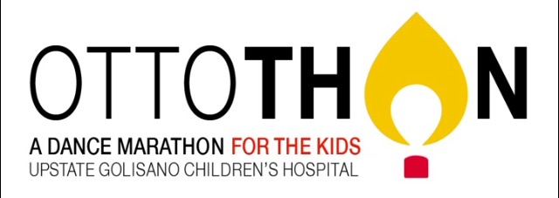
Dear <Donor’s Name>,

I am writing to tell you about OttoTHON, an organization I’m involved in at Syracuse University that supports children and their families at Upstate Golisano Children’s Hospital. The causes of most childhood cancers are unfortunately currently unknown and cannot be prevented. I got involved because I want to help make a difference and take a stand against cancer right here in Syracuse, New York!

Dance Marathon is one of the largest student-run organizations across the nation. Dance Marathon as a program has raised more than 62 million dollars to benefit over 150 hospitals across the nation. This is Syracuse’s second year participating in Dance Marathon, and we hope to create and continue a tradition on campus that raises awareness and money for Upstate Golisano all year long. The year will culminate with a 12-hour BIG Event held in the fall, which will celebrate the children’s fight and remember those who have lost their battle. I pledge that I will NOT sit the entire night in honor of these courageous children.

With your donation, OttoTHON can provide even more resources for families. Upstate Golisano Children’s Hospital is a member of Children's Miracle Network Hospitals, an alliance with two simple goals:

- Help as many children as possible by raising funds for children's hospital services
- Keep funds in the community in which they were raised to help local children
That means your gift to Children's Miracle Network Hospitals will help make miracles happen for children living in Upstate New York who courageously face health challenges greater than most of us can imagine.

Children's Miracle Network Hospitals helps by:
- Paying for expenses not covered by insurance - things like medicines, therapy, hearing aids, wheelchairs, travel to stay with hospitalized children, formula and diapers.
- Providing support services like scholarships to special summer camps for kids and help for parents grieving the loss of a child.
- Helping hospitals and other health care facilities purchase important equipment they could not otherwise afford, like emergency pediatric resuscitation carts, infant car seats for safety, specialized hearing equipment, or playroom toys.
Your donation will help not only help get me to the Big Event, but it will also fund projects and resources for patients at Upstate Golisano Children’s Hospital.

How to Donate
- Donate online: Visit www.events.dancemarathon.com and find OttoTHON and click the "Donate Now!" button. A new page will appear where you will scroll down to the “To a Dancer” section. Click on the “participant list” link. A new page will load where you will type in my first and last name and click "Search." When you see my name and profile click on my name. You will be directed to my online giving page where you can click on "Donate Now" to donate.
- Send a check: If you prefer to donate this was, please make checks payable to OttoTHON and include my name in the memo section so I can get credit for your generous donation.

Last year OttoTHON rasied: $84,013.33
This year we hope to raise: $100,000.00
With your help, I can make it to the Big Event and reach my goal to raise over $100 for children with cancer.
Thank you so much,
<Your Name>

